**HUMAN COMPUTER INTERACTION**

**ASSIGNMENT NO. 2**

**Group Assignment**

**BSE 6A,B 10 Marks**

**Name : Muhammad Shoaib Akhter Qadri Reg No: 79290**

1. Design interview questions and conduct interviews from 2 users per group members to gather user needs regarding chosen prototype application.
2. List down the user needs for the prototype.
3. For the selected prototype, sketch storyboards. Sample is given below for tour guide website.

**SCENERIO #1**

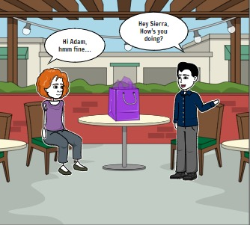 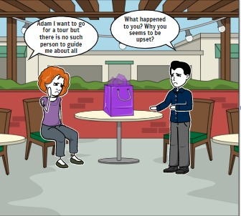

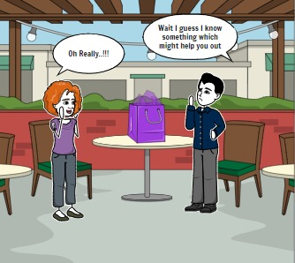 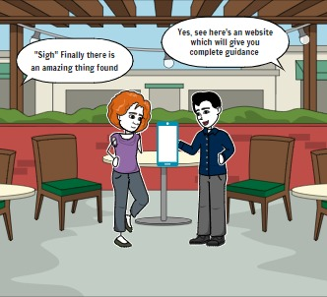

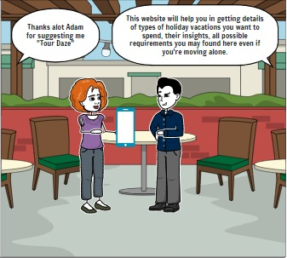 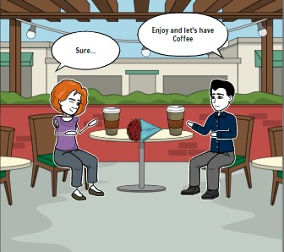

Here are two potential software products:

* A backpacking checklist builder. People who only backpack once or twice a year may spend so much time deciding what to take, running from store to store to pick it up, and packing it, that the trip is more work than fun -- and something usually gets forgotten anyway. This software would produce simple pre-trip instructions and checklists that would alleviate these problems.
* A cooking help system for folks who don't cook often. Many single people cook only infrequently, so they don't have many ingredients on hand in the kitchen. When they do cook, planning and shopping is as much a part of their effort as following the recipe. This software would help the infrequent cook maintain a kitchen with the ingredients common to many meals, and would help plan meals that could be produced (or nearly so) with what was currently on hand.

**Solution:**

**Sketch storyboards and Interview Questions are here:**

**User needs for the prototype** of a bus transportation system would include:

1. Efficient management of bus schedules to ensure timely arrivals and departures.

2. Real-time tracking of buses to provide accurate information to passengers and improve operational efficiency.

3. Seamless communication between passengers, drivers, and administrators for better coordination and service delivery.

4. User-friendly interfaces for passengers to access bus schedules, routes, and other relevant information easily.

5. Integration of digital tools to enhance the overall travel experience and provide value-added services.

6. Accessibility features to cater to diverse user needs, including those with mobility impairments.

7. Safety features to ensure the well-being of passengers and drivers during bus travel.

8. Customizable options for passengers to plan their journeys efficiently and meet their specific travel requirements.

9. Sustainability initiatives to promote eco-friendly practices and reduce the environmental impact of bus transportation.

10. Continuous improvement based on user feedback to enhance the overall user experience and meet evolving needs and expectations.